Group Letter: L- Portifize

Members: Leah, Ella, Ashwin, Avi

Unmodified Prosthetic

1. **Structural Analysis Simulation**

Mass of Prosthetic Foot Subassembly:

1405.30 grams

Identify and describe any regions of high stress:

The region of highest stress is where it bends in the middle.

Do any of these regions exceed the yield strength of the material?

No. Our yield strength value is 8.27e+08 and the region of highest stress is 5.922e+08 so no region exceeds the yield strength of the material.

Calculate the leg stiffness, *kleg*, using equation 1.

Stiffness = force / delta l

= 1250 / (4.91997e-02)

= 25406.65 N

= 25 kN

Use the snipping tool to capture the stress and displacement plots generated in steps 37-42 and paste below:

Stress

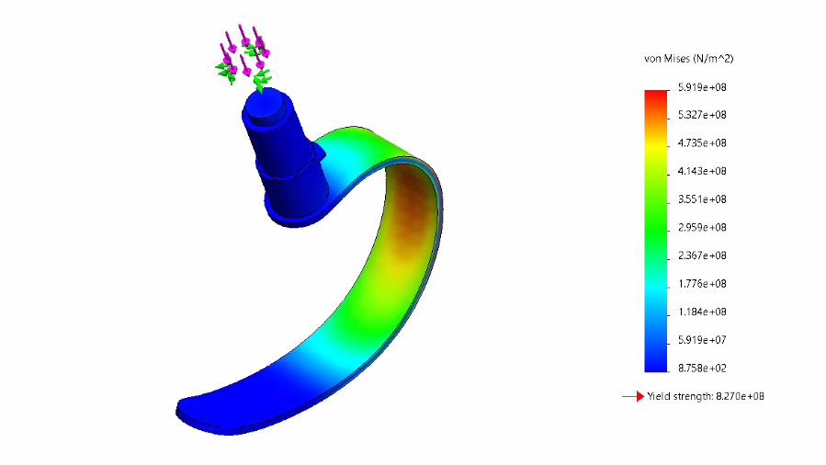

Displacement

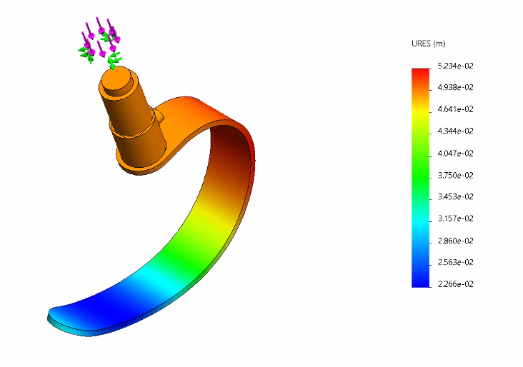

1. **CFD Flow Simulation**
2. Global Max Pressure: 105312.51 Global Min Pressure: 99524. 12
3. Y Force: -14.3 N Z Force: -8.903
4. Drag Force: 16.786
5. Verify drag force using resultant force equation 2

sqrt((-14.3)^2+(-8.903)^2) = 16.84

1. Use the snipping tool to capture the cut, surface and flow trajectory plots generated in steps 45-60 and paste below:

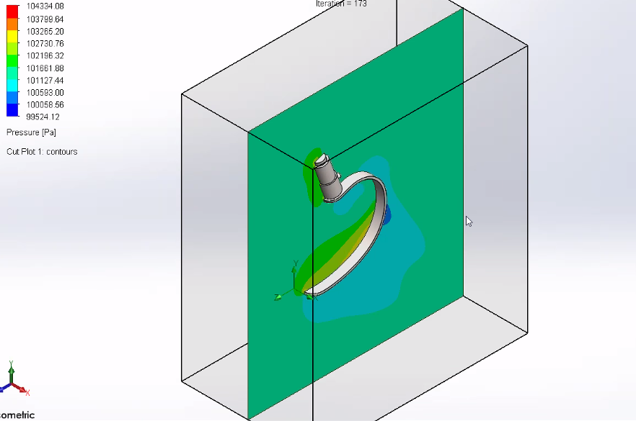

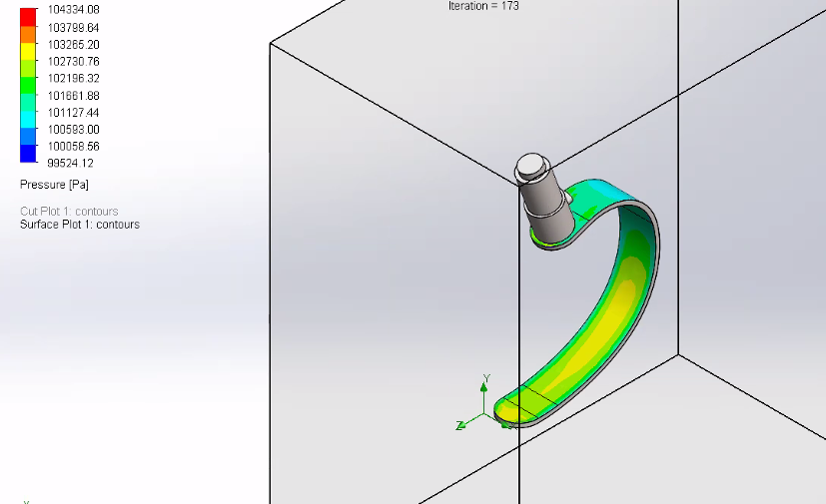

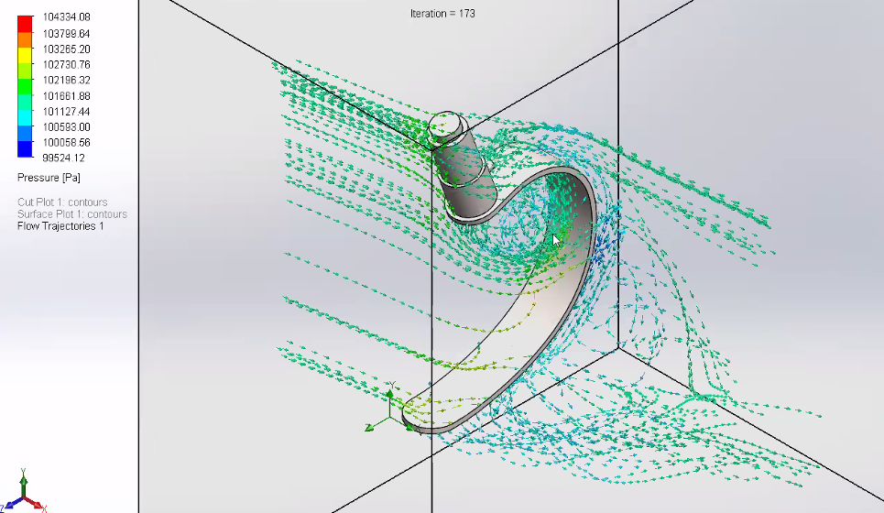

Design #: D1

Why did the team choose to analyze this design?

Because we believe that the opening inside the foot will enable the foot to reduce the amount of drag it experiences, thus making it more Aerodynamic.

1. **Structural Analysis Simulation**
2. Mass of Prosthetic Foot Subassembly: 1.37 kg
3. Identify and describe any regions of high stress

The region of high stress is around the spot where the prosthetic leg bends a lot in other words towards the middle section of the leg.

1. Do any of these regions exceed the yield strength of the material?

No none of the regions exceed the yield strength as the majority of the highest tension spot stay at 5.687e+08

1. Calculate the leg stiffness, *kleg*, using equation 1.

Stiffness = force / delta l

= 1250 / (3.96353e-02)

= 31537.54355 N

= 31.537 kN

1. Use the snipping tool to capture the stress and displacement plots generated in steps 37-42 and paste below:

Stress

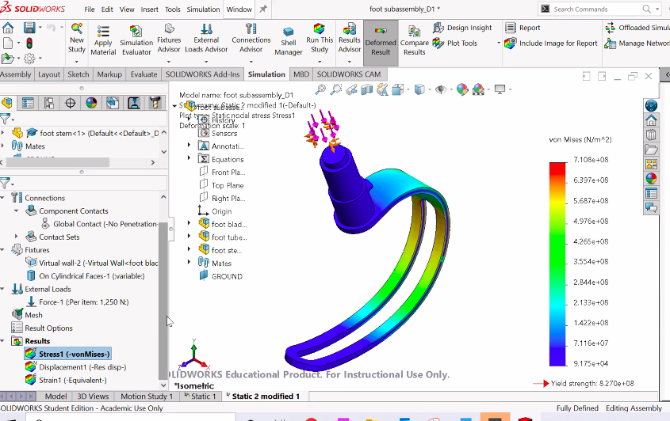

Displacement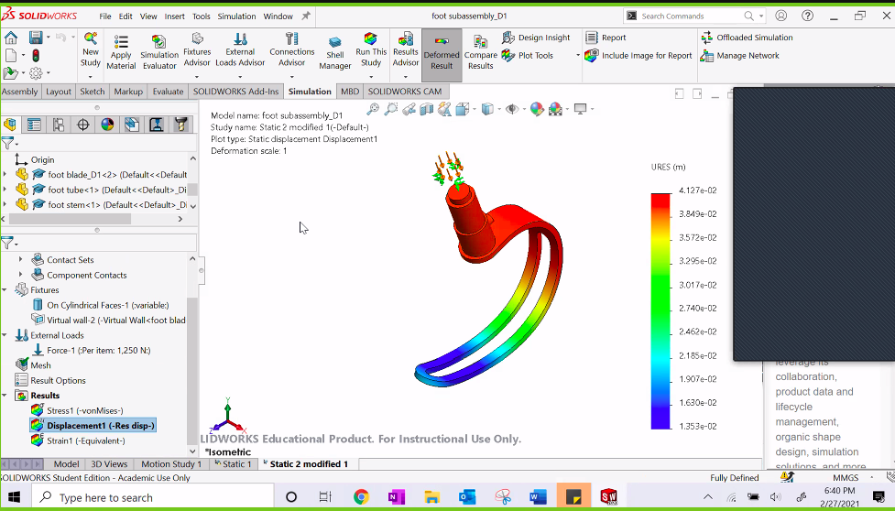

1. **CFD Flow Simulation**
2. Global Max Pressure: 109206.82 Global Min Pressure: 98912.62
3. Y Force: -9.176 Z Force: -3.373
4. Drag Force: 9.777
5. Verify drag force using resultant force equation 2.

sqrt((-9.176)^2+(-3.373)^2) = 9.7763

1. Use the snipping tool to capture the cut, surface and flow trajectory plots generated in steps 45-60 and paste below:

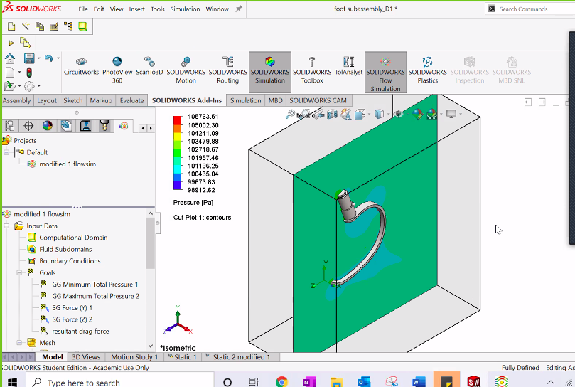

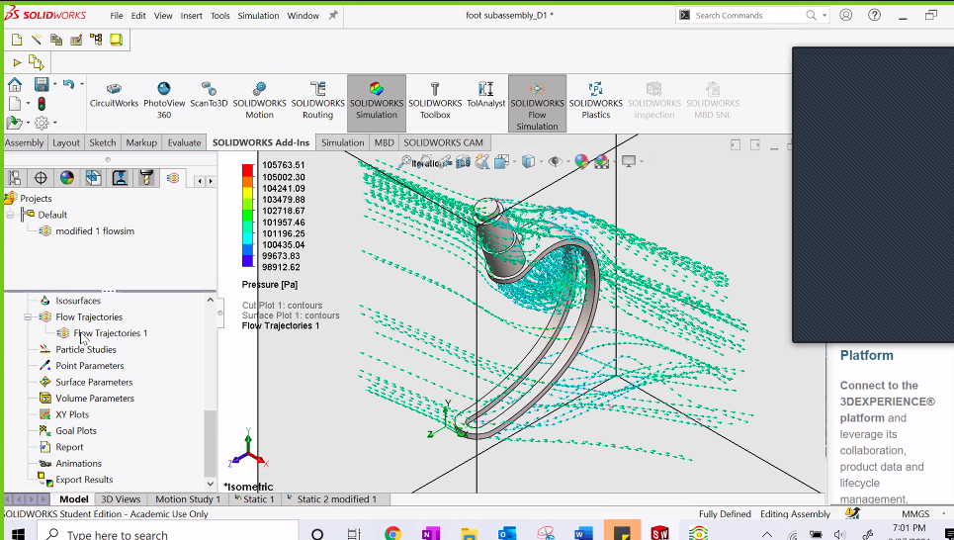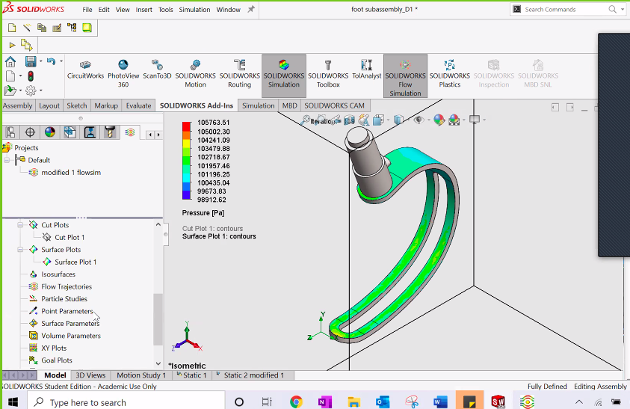

Based on the analysis, how does this design compare to the original?

Based on the analysis of part D1 we noticed that when compared to the unmodified prosthetic we can see that the largest area of tension on both prosthetics was near the upper middle part of the blade. Both of these areas expressed the highest tensions on both designs. However, when specifically examining the values of the tension, D1 demonstrated to be slightly higher than the unmodified prosthetic. I believe this happened because there is less surface area on the D1 blade as the entire middle of the blade is cut out. Another thing that was different was that with the D1 design the fluid mechanics of that design were a lot more efficient compared to the unmodified design because with the help of the opening at the middle of the blade on D1 more water was able to flow through the prosthetic creating a more fluid motion for the water to travel which in turn decreased the amount of drag/resistance it experiences in the water.

Design #: D5

Why did the team choose to analyze this design?

We chose to analyze this design because...

1. **Structural Analysis Simulation**
2. Mass of Prosthetic Foot Subassembly: 1.482 kg
3. Identify and describe any regions of high stress

The region of high stress is around the spot where the prosthetic leg bends a lot in other words towards the middle section of the leg.

1. Do any of these regions exceed the yield strength of the material?

No none of the regions exceed the yield strength as the majority of the highest tension spot stay at 6.003e+08

1. Calculate the leg stiffness, *kleg*, using equation 1.

leg stiffness = F/delta L

= 1250/ 3.705e-02

= 33.738 kN

1. Use the snipping tool to capture the stress and displacement plots generated in steps 37-42 and paste below:

Stress

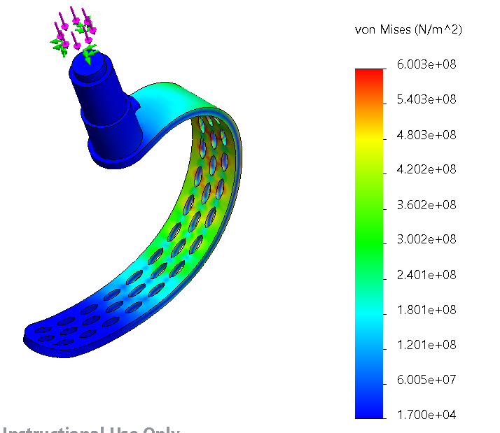

Displacement

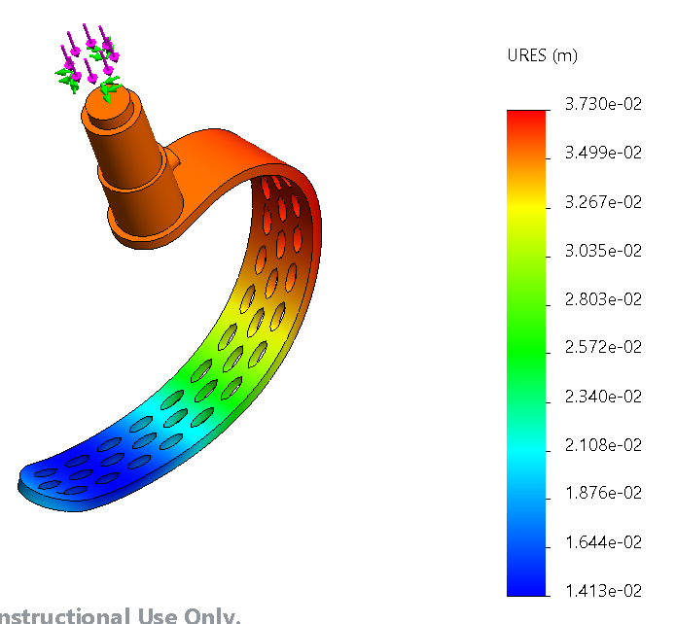

1. **CFD Flow Simulation**
2. Global Max Pressure: 109373.23 Pa Global Min Pressure: 99259.30 Pa
3. Y Force: -11.294 N Z Force: -6.201 N
4. Drag Force: 12.884 N
5. Verify drag force using resultant force equation 2.

sqrt((-11.294)^2+(-6.201)^2) = 12.884

1. Use the snipping tool to capture the cut, surface and flow trajectory plots generated in steps 45-60 and paste below:

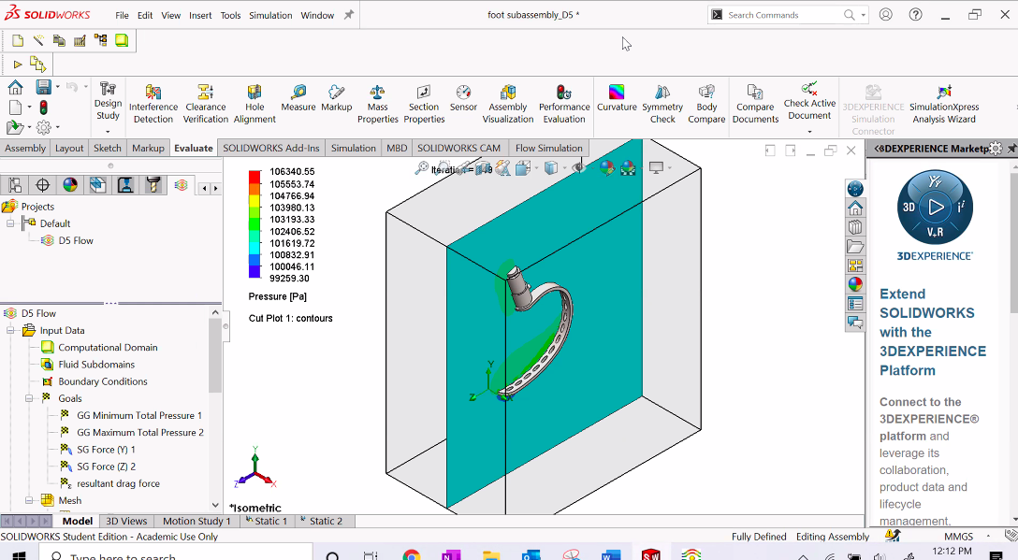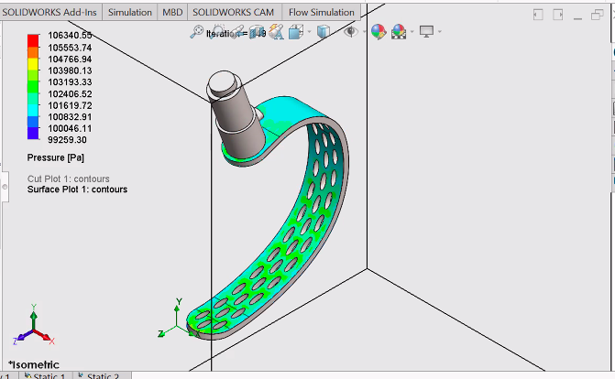

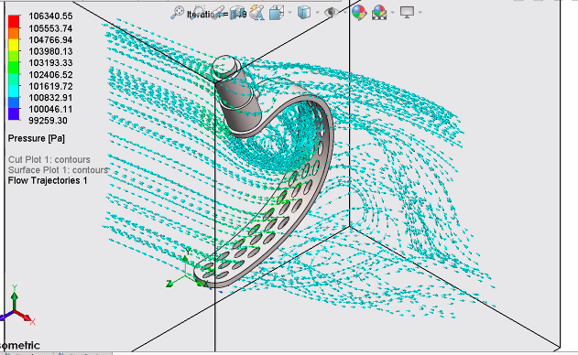

Based on the analysis, how does this design compare to the original?

This design, compared to the original, is more aerodynamic (e.g., it would move through water more easily) than the original. This is because in this design, the water is able to move through the leg due to the holes, rather than having to move around the leg like in the first design which would create more drag. This design also appears to be generally more durable to stress than the other two designs as the distribution of stress is more even across the part and the stress itself is less intense.

Additional Questions:

1. The simulations only model behavior of the prosthetic at one specific position or instance of time. Consider how these designs might behave at other instances throughout the run/swim (i.e. when the runner’s leg is up in the air, or when the swimmer’s leg is moving upward). Leah

The original leg is less aerodynamic than the first modified version. Because of this, the modified version would probably perform better during the run or bike; however, it might not be the best option for the swim since the water would go right in between the two vertical pieces and it would be more difficult to paddle. The third leg is somewhat aerodynamic, and might be the best choice among the three options. Also, after multiple iterations of the leg hitting the ground after being in the air, the leg will become weaker, so it is important to use a design that will be able to withstand constant and high amounts of pressure.

1. Does the added value of this modified RSP give an unfair advantage over non-amputees? Explain. Ashwin

At the current state of RSP (Running-Specific Prosthesis) I believe that they do not give an unfair advantage over non-amputees. Based on where current prosthesis technology is at today they do not give unfair advantage but rather they provide the ability to give the ability of movement back into the hands of amputees. However, technology and science is always changing and it is constantly improving everything we touch, so in the future by making the legs more aerodynamic and and changing them to better improve the speed and function of the user then it can definitely be considered an unfair advantage. Which, at that moment, I do not propose we stop improving upon prosthetics but rather place regulations on what specific prosthetics can be used during competitions and rather allow the improved legs for everyday use. This way innovation and change can continue to happen while also keeping it fair for all competitors of a competition.

1. Other than those collected in this study, are there other design characteristics that should be considered in future development? Avi

Following design characteristics should be considered in future development:

i. Padding material for stump attachment: The pain point of any prosthetic is the stump attachment. Therefore design considerations of material that would make this attachment less painful will benefit.

ii. Foot design for impact Absorption: Since it would be great to have a single prosthetic for all the three events of triathlon, a foot design that will help in maximum impact absorption in various terrains will be helpful.

iii. Decreasing the mass by trying various polymers: Since decreasing the mass will decrease the amount of force required for any activity, it will reduce the stress incurred by the knees of the athletes making them endure longer distances. Many new polymers with different properties are widely available and should be considered for designing these prosthetics.

iv. Adaptability with different shoes for different terrains: Since these triathletes will need to compete in different terrains, like any non-amputee they should be able to wear different shoes for different terrains. Therefore the material of the foot should be shaped in a way that the final prosthetic could have all the curves required for wearing different types of shoes for different terrains.

1. Is an 80kg (176lbs) male an appropriate representation of the target user for this product? Why or why not?

For a male triathlete, the highest performing body weight ratio is 2.1-2.3 pounds per inch of height. At the high end of the height spectrum and at the high end of the weight ratio at 2.3 pounds per inch, a 6’ 5” male athlete would weigh 177 lbs. Because many female triathletes will inherently weigh less than this estimate, and many male athletes would not typically be that tall, 177 lbs represents close to the max weight of a user of this product. However, it must also be considered that not all triathletes would be in the target height-to-weight ratio range, so some users will be above the 176 lb representation. Overall, 176 lbs is an accurate representation of the target user for this product, but does not encompass all possible user weights.

1. Assistive devices are prohibited in Olympic events such as triathlons. Discuss the impact of this regulation on this scenario. Leah

One of USA Triathlon’s rules says,”No paticapte shall use any equipment which the Head Referee determines to be improper, including but not limited to equipment which might provide an unfair advantage or endanger other participants. Unless otherwise provided for in these rules, any violation of this section shall result in a variable time penalty.” <https://www.teamusa.org/usa-triathlon/about/multisport/competitive-rules>

This means that in creating a prosthetic leg, it is important that it simulates a real leg as closely as possible to be compliant with this rule so that the athlete can still compete. It would note be fair for someone to have a prosthetic leg that makes it easier for them compared to the other athletes. The goal in creating such a device is not to make it easier for the amputee, but to allow them to be at the same level as their fellow athletes. This way, it is fair competition. In the case of coming up with a potential design, it is important to consider any aspects that might give the athlete in need of the device an advantage, such as how aerodynamic it is, or how springy it is (e.g., would it help to propel the person forward more than a non-amputee would be propelled forward by their own feet?).

|  |  |  |  |
| --- | --- | --- | --- |
| **SW R&D Assignment** | | | |
| **Project Manager for Assignment** | | | |
| Ella Wulforst | | | |
| **Deputy Manager for Assignment** | | | |
| Leah Norton | | | |
| **Drafted Assignment** | **Reviewed Assignment** | **Revised Assignment** | **Proofread Assignment** |
| Ella Wulforst | Leah Norton | Avi Popat | Ashwin Rajkumar |
| **Created Figures** | | **Created Tables** | |
| Leah Norton | | Ashwin Rajkumar | |
| **Other Contributions** | | | |
| N/A | | | |
| **Problems Overcome** | | | |
| N/A | | | |